Classroom Management Philosophy Paper

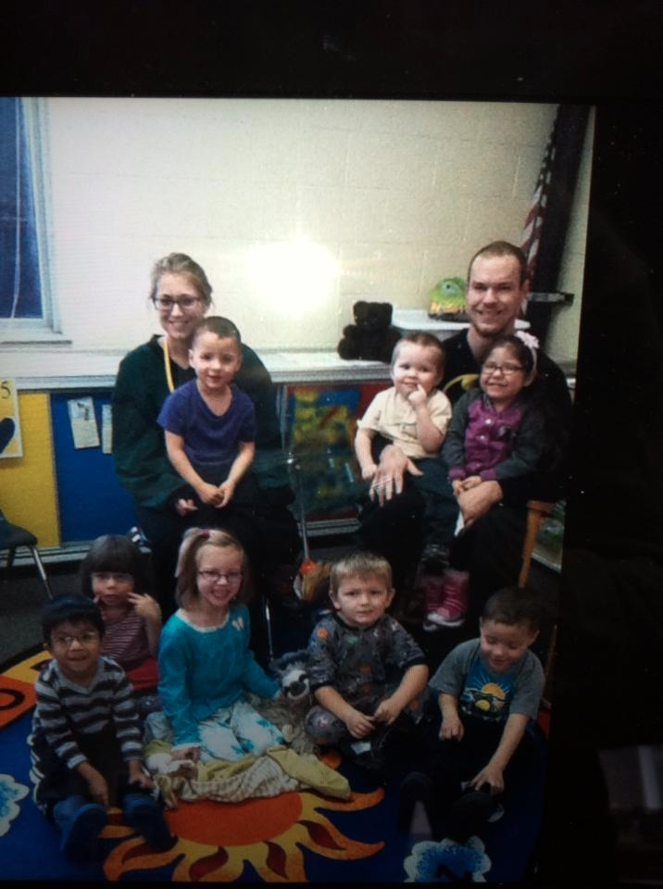

By: Zac Steffen

My Classroom Philosophy
To begin, like Alfie Kohn, I believe that each classroom should be like that of a small community and that when a student enters my classroom they become apart of “the family”. In order to obtain the goals we set out to achieve we must lean on one another to become successful. Each student, as well as myself, must have the ability to work with one another so that we can celebrate the achievements made as well as, build on the areas where one is not finding great success. The students must be aware of each student’s disability and show patience in their time of struggles. Right from the start I will introduce my classroom standards and expectations, which we will practice daily to assure that we, “the family”, can reach the ultimate success we are striving for. It is important to me that we invest in one another’s needs while still respecting the differences we have. Having a classroom with different ethnicities, races, religions, cultures, and specific learning needs will allow the students and myself numerous opportunities to celebrate our differences and strengthen our bond as a class. This will be a great opportunity to allow the students to open their eyes and see all the diversity in the world they live in. If we can all accept one another’s talents, we are creating a warm and friendly environment that will allow each student to feel comfortable and reach their full potential.

Because my class features a family setting, each student will receive as much help and support as I can give them in order to help them stay as motivated as possible. That being said in order for a family to fire on all cylinders, each piece must work together to achieve ultimate success. This means that I must develop each student to be a “team player” and help others when I am unable to. Like Alfie, I plan to implement the “teamwork” strategy, each student will have many opportunities to help others when I am not available, lead parts of a lesson, pick others up when they are struggling, and ultimately reach the goal of becoming an independent problem solver. This means that my classroom will have ample amount of group work where the students will be encouraged to be vocal in sharing their own ideas, as well as building off of other students ideas. I whole-heartedly believe that if I remain positive, provide encouragement where it is needed, and stress the importance of teamwork, that my students will be compelled to do the same. I hope the students quickly understand that each individual has strengths and weaknesses, but it is how we utilize one another’s strengths to build on our weaknesses.

Classroom setup:
The way we as teachers structure our classroom has a huge impact on the student’s mood and motivation while they are at school. I have to make sure that my classroom setup creates a warm and welcoming environment that leads to confident and motivated students. I really connected with the way Alfie set up most of his classroom having multiple activity centers, a place to display student work, and ample amount of materials and supplies. Included in my classroom layout would be:
-A class pet/plant -Teachers desk -Shelves for storage -Rug for whole group discussion -A small group collaboration table - Comfortable area for reading -Mobile Computer Lab
-A lot of signs and posters to enhance learning -A student bulletin board to display their work
-Single desks to allow for personal space/independent work -1 bookshelf for academic resources -1 bookshelf for fun reads -Whiteboards

W
H
I
TE

BOARD
Collaboration
Rug
Mobile
Lab
Reading Area
Collaboration
Table
Bookshelves
Class pet/plant
Desk
Desk
Desk
Teacher
Desk
Desk
Desk
Desk

Storage Shelves

Some quotes and posters I would like to have on a wall in my classroom includes: Mother Teresa, “Believe that together we are better. What I do, you cannot do; but what you can do I cannot do… We can all do small things, with great love, and together we can do something wonderful.” This quote is extremely important for each student to see daily. Each student has a gift or talent that someone in the classroom, including myself, might not have. As a family, we must accept this but know that we are all assets in our own way. Another poster that will be hanging in my room to help remind me to make sure I have strong relationships with my students is some of Ronald Morrish’s Guidelines for Strengthening Student Relationships. This poster will remind me to, 1) Consistently focus on the positive 2) Wipe the slate clean after students make behavioral mistakes 3) Not back away from discipline but instead face it head on right away 4) Lead the way, instilling the amount of care had for the student 5) Never humiliate students when correcting their misbehaviors 6) Refuse to accept mediocrity and holding students accountable to high standards (Ronald Morrish’s Guidelines for Strengthening Student Relationships, Charles, 2014, pg. 85). Lastly, “The best time to teach a behavior is when it isn’t needed. Today’s practice is tomorrow’s performance.”-Ronald Morrish

Motivation
One of the biggest struggles that teachers and parents tend to face is keeping the students motivated. I will tackle this problem by first connecting with the parents of each student before school begins and figure out more about their child and how I can reach him a little easier. Showing the parents that I am willing to put in extra, off-the-clock effort, will hopefully get the message across to them that I want to invite the parents to become apart of our “family”. By doing so, I am putting myself in place to make a relationship with the parents of my students, giving myself a line of communication should something come up where I need to contact them, and having out of school reinforcements in tracking and supporting the students progress throughout the year. I will relay to each parent that I am willing to try anything they feel might help their child in my classroom, but it must be communicated to me. This includes modifying instruction and changing up the classroom structure. Also, communicating with the parents prior to class will help me figure out what makes each student tick and also different techniques to try and motivate the students. This communication will allow me to get to know background on the students prior to actually meeting them face-to-face.
My three main ways to enhance student motivation is:
-Show a personal interest in the student and their successes and failures.
-Incorporate students’ interests into what they are learning and what is being taught.
-Give the student’s choices/options

Each student is completely different in their own way and therefore, has different desires and interests. There isn’t a universal interest or motivator for each kid in the room so I will try to incorporate some of each student’s interests into different lessons if applicable. My goal is to ignite flames of interest in each student by coming up with many activities and projects that incorporate different methods of learning. Each student will be more interested and motivated to learn new things when I can make more and more connections to class material and their own personal interest. Not only will that make the student more interested in learning but it will help them grasp new concepts because it might relate to an interest they may have. Throughout the year, I will give many open-ended assignments where the students are given a topic but can choose how they want to tackle accomplishing the assignment. In the first few weeks, the students will participate many icebreaker and team building activities to get to know one another better and really drive home the “family” theme I am trying to instill. The students will hopefully create a deeper bond with myself and their peers through conversations and connections made in class, but I believe that the students will see my care and passion for their needs through how I portray myself and the body language I show in the classroom. Students of any age can read adults like books because of the body language given off. This makes it imperative for me to keep composed and constantly let my passion for the students shine through. Lastly, I feel that giving the students options is huge when teaching. In some instances, this allows the students to decide for him or herself, what they want to do or where they want to do it. I believe this is key because NO student wants to constantly be told what to do how to do something, and where to do it every step of each day. By giving them choices you aren’t giving a command, but instead allowing them to make a decision given certain options.
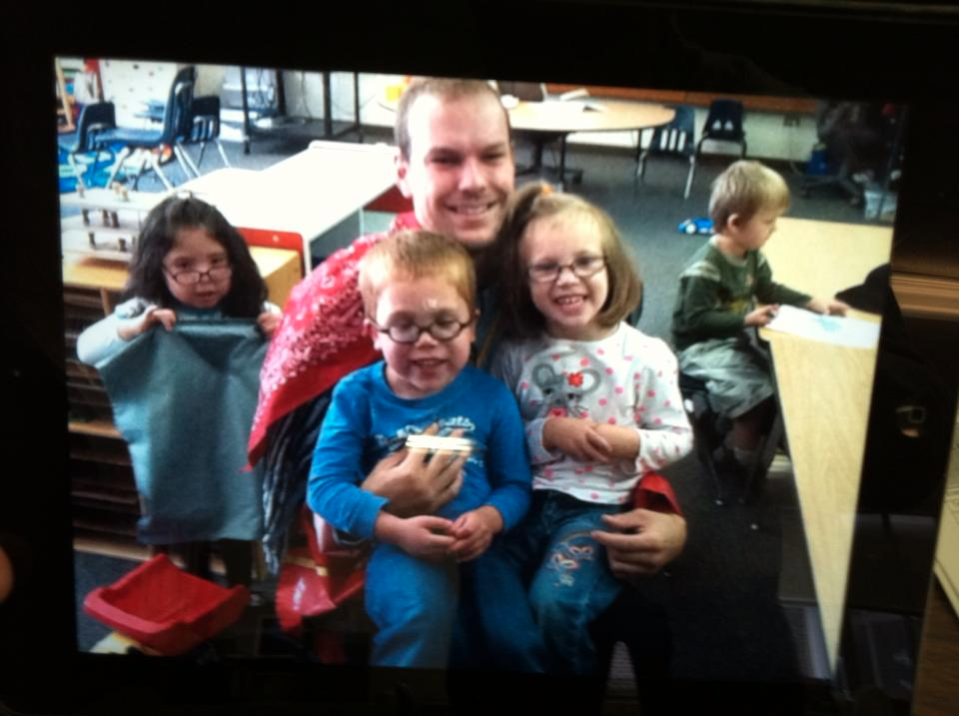

Win-Win Discipline
Win-Win discipline is a classroom discipline concept Spencer Kagan focused on. I plan on incorporating this into my classroom because the goal of this is to improve and instill responsible lifelong behaviors. The process includes three main points: 1) Same side: students, teachers, and other staff work together (group work) 2) Collaborative solutions: student and teacher collaborate side-by-side (1 to 1 ration student/teacher) 3) Learned responsibility: student applies self-management practices (individually done) (Charles, 2014 pg. 209). By working together, over time, the concepts are eventually given to each individual student in the classroom. As teachers, we want students to get comfortable having responsibilities for their actions and transfer that responsibility to their hands. It is my job to provide my students with the appropriate tools to properly manage their own actions.

Field placement teacher’s motivational tactics
Jen Jongekryg is my current field placement teacher at Holland West. She is currently teaching the Emotional Impairment elementary classroom which can have students from Kindergarten through fourth grade. Jen is ALWAYS trying to figure out new ideas to help the students grasp concepts easier and figure out new ways to motivate her students. Although she is only in her third year teaching, she has found that it helps students with disabilities to have tangible objects to best support their learning experiences. She is constantly figuring out new constructive incentives to present to the students in an attempt to keep them motivated to learn more. Here are a few examples of some of the manipulatives/incentives I have seen used in her classroom and plan to incorporate into my own.
-Breaks to the AI room -Twix/Starburst/Jolly Ranchers -Fruit/Vegetables
-Playing cards -Computer time -Plato -Hot Wheels -Smiley Face Stickers -Extra Reading time
Classroom Rules and Procedures
In my classroom, there will be procedures and rules to help the students stay on task and well behaved. The students will not be expected to get everything perfect right away, and I will be sure they know this right away. However, I do expect the mistakes to decrease more and more over time but also want the students to know that each mistake is an opportunity for them to learn from their mistakes as well as others. When a mistake does occur, I will take it as an opportunity to walk the individual or the class as a whole, depending on the mistake, through my guidelines and procedural policy. Ronald Morrish makes note that as teachers we are to teach behaviors when it is needed the least. This way the student can practice the proper way and use it when it is needed. The first few weeks of school will be used to gain a rapport with each other and to train for the yearlong expectations I have. This will be done through daily practice of the procedures and continuing to go over my guidelines and the standards I have for my classroom until I feel that the students can make the proper decisions without needing to take the time to think about the different guidelines and procedures. I have hopes that in those first few weeks I can make it more of a second nature for them. I am not expecting perfection out of my students and will let them know that right away.
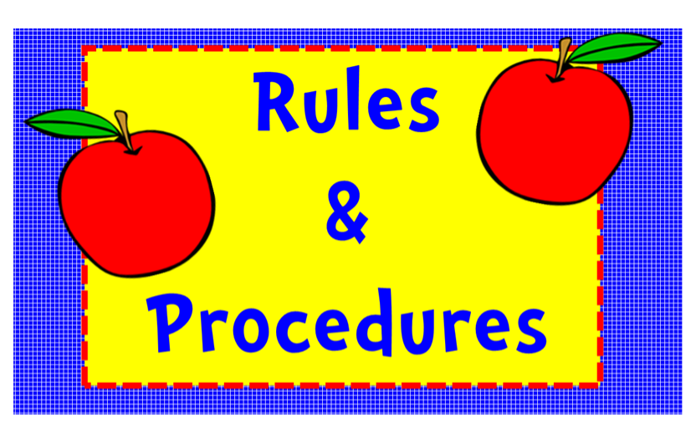

My classroom rules will be posted directly above my white board in the front of the room so the student will always be able to see then and it will make it easy for me to refer to them when needed with only a hand motion towards that direction. The rules I want incorporated into my classroom are: 1) Always give Effort. Are you giving it all you have? Can you do any better? 2) Show perseverance. Are you trying? Did you ever try to do it a different way? 3) Community. Are you helping your family members? What could you do to help someone out? 4) Integrity. When there is no one watching, are you doing the right thing? Are you being honest? 5) Positivity. Are you lifting yourself and others up? Not only will I have those rules of my own ready to establish but I will also allow the students to come up with some rules of their own that I did not include. These rules are to be short and simple to make it easy for the students to remember. By doing this, I am collaborating with the students and again providing them the opportunity for them to share their thoughts on how they would like the classroom to be driven to. When the students have completed their list of rules, we will go through the list as a class and determine which five they feel are most important and helpful. Once we have come to an agreement on these five rules we will make a poster as a class to hang next to my rules for the students to always refer back to. At the beginning of the year, we will again take a week or so to talk through what the students think each rule means and how we might use each one in the classroom setting. I plan to incorporate different books that the students would enjoy that touch on each of these rules and figure out ways I can fit them into lessons throughout the year. If I see a student veering away from one or more of the class rules I will take the time to ask the questions listed after each rule to remind the student that his actions are not coinciding with what I have established as our classroom rules. These will not only be used when a student is not following the rules but when they are following them as well. I see each day in my field placement how much praise my placement teacher provides each student to try to encourage other students to do the same as well as give them the proper acknowledgement for doing what was asked. Once I see that the students have grasped the classroom rules I will then place the responsibility of following these rules in their hands and expect them to be class leaders. Once again, I am not expecting perfection but I am expecting improvement. It is important for the students to feel comfortable making mistakes as long as they know that each mistake made is merely one more opportunity to learn and grow from it. These rules were chosen because not only are they helpful and apply to my class, but they also can be used in their everyday lives going forward. Being a teacher is not only about molding a scholar, but also molding and strengthening individual’s everyday life skills. Some procedural posters I have seen in my placement now as well as others in the past that I would like to have in my future classroom are the 4S line: Silent, Still, Straight, Smiles and the hard work poster (JOBS): We work hard when we do our… Just do it. Optimize time. Be respectful of others. Smile!
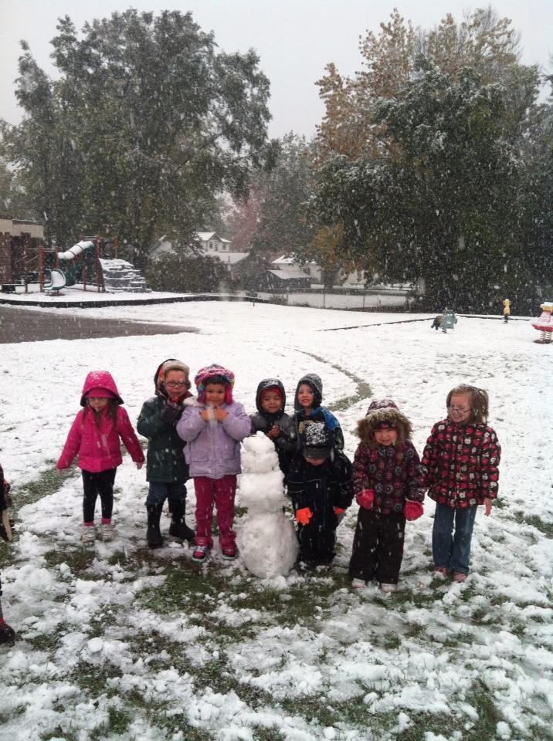

Sources:
Charles, C. M. (2014). Building classroom discipline (11th edition). Upper Saddle River, NJ: Pearson.

